

**MECHATRONICS SYSTEM INTEGRATION (MCTA 3203)**

**SECTION 2, SEMESTER 1, 2024/2025**

**ACTIVITY REPORT**

**Week 6:**

DAQ interfacing with Microcontrollers.

| **No** | **Name (Group 6)** | **Matric No.** |
| --- | --- | --- |
| **1** | **MUHAMMAD BASIL BIN ABDUL HAKIM** | **2215315** |
| **2** | **MUHAMMAD SYAFIQ BIN NOR AZMAN** | **2213187** |
| **3** | **MUHAMMAD HAFIZ HAMZAH BIN FANSURI** | **2212803** |
| **4** | **MUHAMMAD AMMAR ZUHAIR BIN NOR AZMAN SHAH** | **2110259** |
| **5** | **MUHAMMAD RAZIQ BIN KAHARUDDIN** | **2120225** |

# Table of content

# 

**Table of content 2**

**Abstract 3**

**Material and equipment 4**

**Experimental Setup and Methodology** **5**

**Results 7**

**Discussions** **9**

**Recommendation 1****3**

**Conclusion 1****4**

**Student Declaration 1****5**

# 

# Abstract

This experiment explores the Data Acquisition (DAQ) system comprising sensors, DAQ hardware, and a computer for data collection and analysis. The system utilises an Arduino as the DAQ device to process data from sensors and transmit it to a computer. PLX-DAQ, an Excel add-in, is employed to organise the received data into spreadsheets, simplifying analysis for applications such as sensor experiments and real-time monitoring. LM35 and LDR sensors were used as the analogue input sensor, with its data being processed by Arduino and logged in Excel. The integration of these components highlights the effectiveness of Arduino and PLX-DAQ for accessible and efficient data acquisition and analysis.

# Material and equipment

1. PLX-DAQ software
2. Arduino Uno microcontroller
3. LDR sensor
4. LM35 sensor
5. Jumper wires (male-to-male)
6. Resistors, 200 ohm
7. Breadboard

# Experimental Setup and Methodology

# Figure 1

# Figure 2

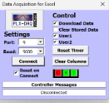

# Figure 3

# The circuit in Figure 1 is constructed.

1. Arduino IDE is launched and the codes in Figure 2 are written.
2. The codes are verified and uploaded into an Arduino microcontroller.
3. PLX-DAQ spreadsheet is launched. In the GUI (Figure 3), the correct COM port number (port 9) and the baud rate (9600 Baud) are ensured to be the same as the one written in the codes.
4. Once that was done, the connect tab was pressed, and the data from the Arduino was displayed in the spreadsheet.
5. The output is printed onto the spreadsheet and necessary graphs are plotted based on the desired data needed.

# 

# Results

The experiment successfully demonstrated the functionality of the PLX-DAQ software in combination with an Arduino DAQ device to record and monitor sensor data within a Microsoft Excel environment. The Arduino code was effectively developed to process analogue signals, converting them into digital values and transmitting the data serially to a connected computer for real-time analysis.

Using two sensors, an LDR for measuring light intensity and an LM35 for measuring temperature, data was captured and recorded in Excel via the PLX-DAQ software. The recorded data allowed for easy observation and analysis of temperature and light intensity over time. The setup proved efficient for capturing and visualising environmental data, and it suggests the potential for further investigations into correlations between temperature, light intensity, and other environmental factors.

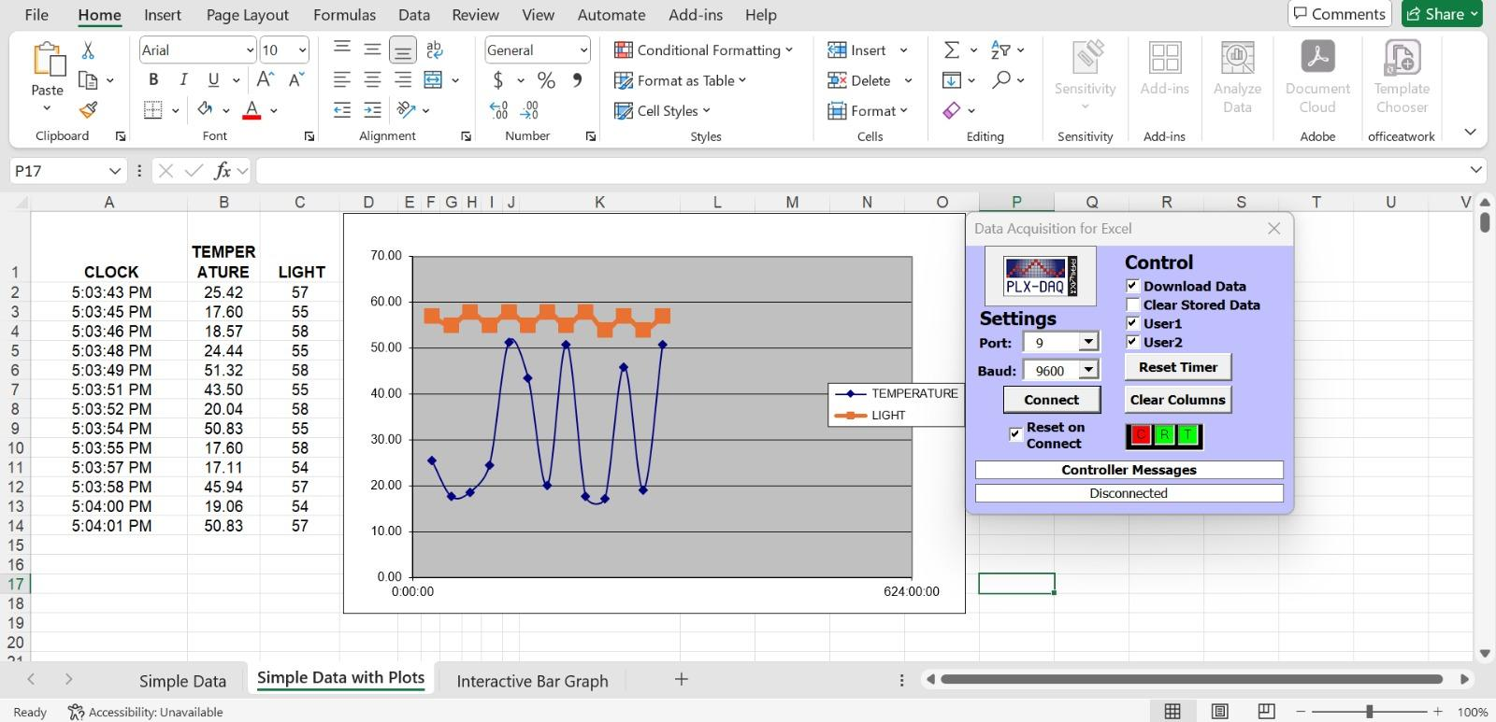Figure 4

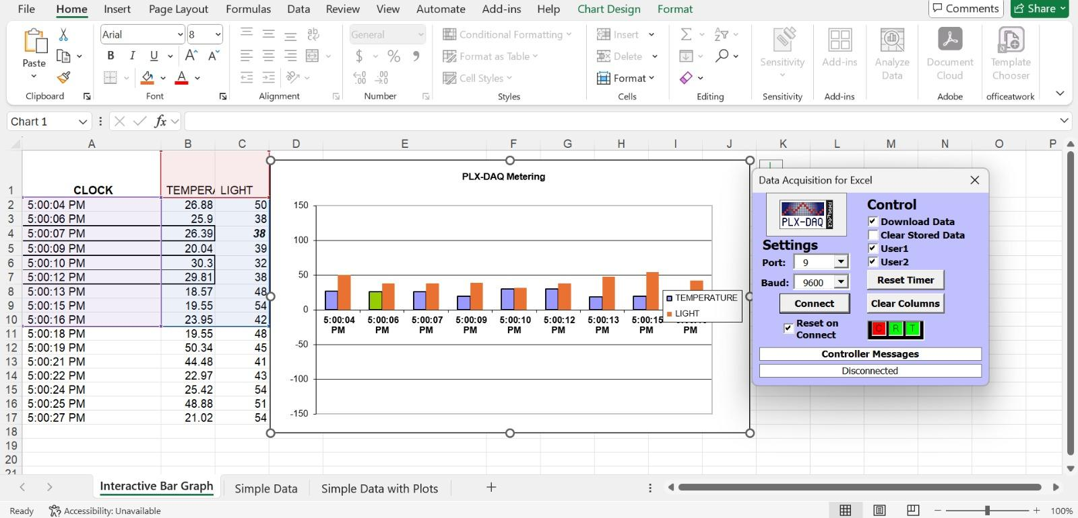

# Figure 5

The images show data from an Arduino connected to Excel using PLX-DAQ software. The Arduino reads from the two sensors stated earlier; LDR and LM35.

On the left, there’s a table with recorded times, temperature, and light levels (Figure 4). The chart next to it visualizes this data, with the blue line showing temperature changes and the orange line showing light levels over time.

Meanwhile, the bar graph in Figure 5 visualizes these values over time. The blue bars represent temperature readings, and the orange bars represent light intensity.

This setup successfully captures and displays real-time sensor data in Excel, making it easy to observe temperature and light variations.

# 

# Discussions

Hardware Discussion

1. **Breadboard**

Breadboards are used to connect electronic components without the need of

soldering.

1. **Arduino board**

Arduino, which comes in many forms, is a microcontroller that can be integrated into many electronics projects by utilising its pin and be controlled by programming.

1. **Wire/ Jumper cable male-to-male**

Wires are used to connect electrical components.

1. **LM 35 sensor**

A temperature sensor that outputs an analogue signal which is proportional to the instantaneous temperature.

1. **LDR (Light Dependent Resistor)**

A special type of resistor that works on the photoconductivity principle means that resistance changes according to the intensity of light

Software Discussion

ARDUINO CODE

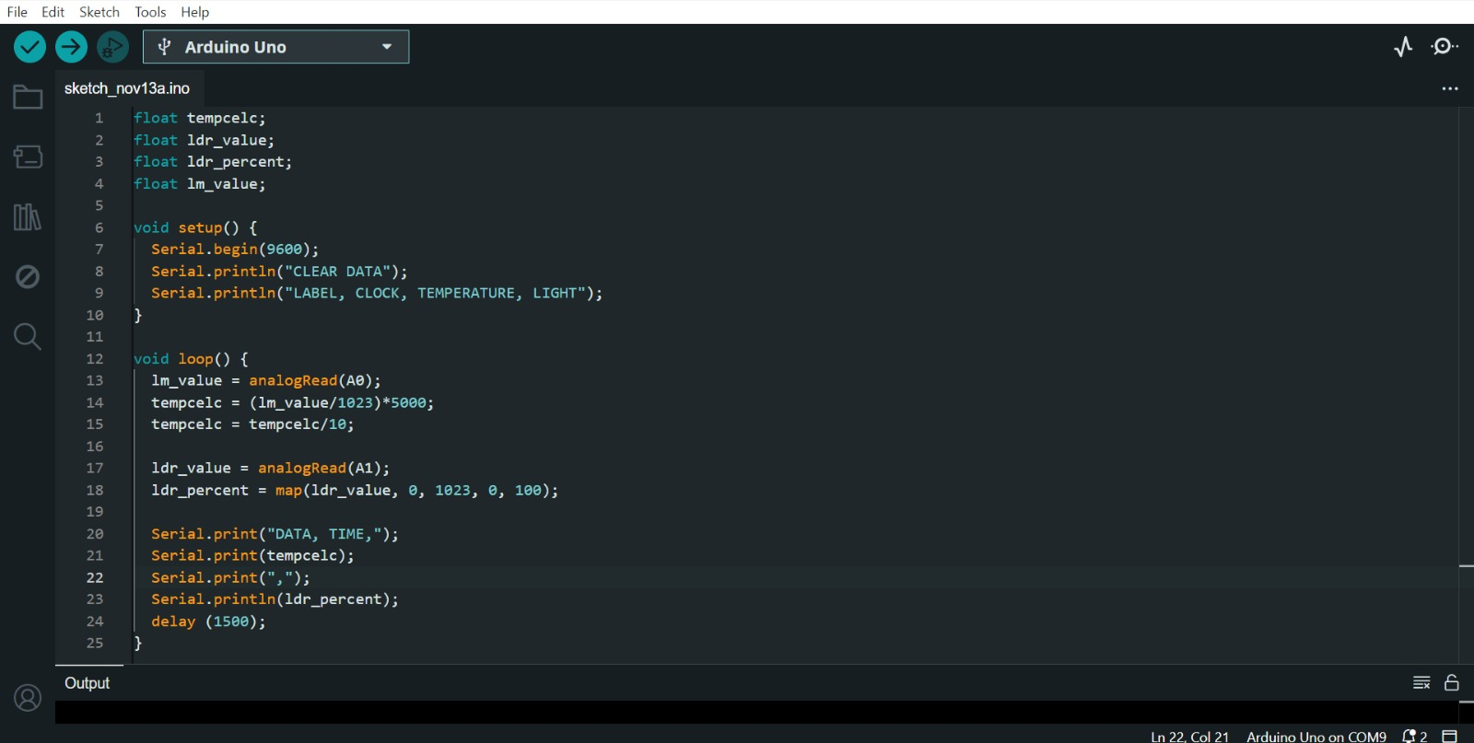

1. **Variable Declaration:**

The code employs variables to hold sensor information, including those for both the raw and processed temperature readings from the LM35 and the light intensity data from the LDR. Floating-point variables (float) are utilised for enhanced precision.

1. **Setup Function (setup()):**

This function sets up the Arduino, initialising serial communication to allow data to be transmitted to the Serial Monitor for monitoring or analysis. It also prints header labels to organize the output, making it simpler to read or use with data-logging software.

1. **Main Loop Function (loop()):**

The Arduino consistently collects data from the LM35 temperature sensor and the LDR sensor. The analogue reading from the LM35 is transformed into a temperature reading in degrees Celsius, while the analogue output of the LDR is converted into a percentage that indicates light intensity. The obtained temperature and light data are subsequently transmitted to the Serial Monitor for live display or logging. A short pause is then implemented to regulate the frequency of data collection before the loop restarts, ensuring measurements are taken periodically.

Electrical discussion

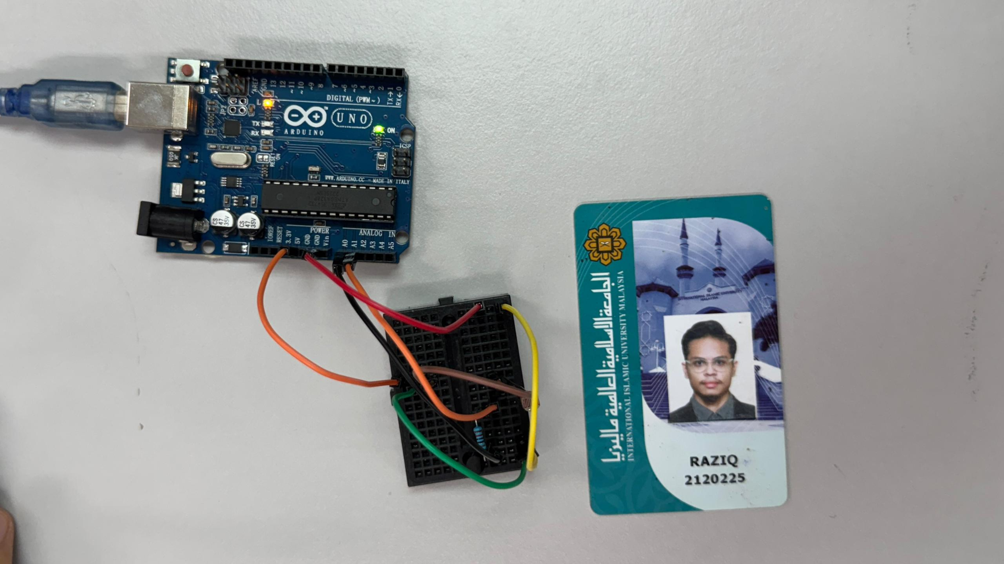

In this experiment, the LM35 temperature sensor and the LDR (Light Dependent Resistor) are connected to the Arduino Uno, as depicted in the diagram. The LM35 sensor features three pins: VCC, GND, and Signal. The Signal pin is connected to analogue pin A0 on the Arduino, allowing it to read the analogue output corresponding to temperature. The VCC pin connects to the 5V supply from the Arduino to power the sensor, while the GND pin connects to one of the ground (GND) pins on the Arduino.

The LDR is configured in a voltage divider setup along with a pull-down resistor. One end of the LDR connects to the 5V supply, while the other end connects to analogue pin A1 and one terminal of the pull-down resistor. The other terminal of the resistor is connected to the ground (GND). This configuration creates a varying voltage at the midpoint between the LDR and the resistor, which changes according to the intensity of light falling on the LDR. The Arduino reads this voltage through analogue pin A1, allowing it to monitor variations in light intensity in addition to temperature data for the DAQ experiment.

# Recommendation One of the most important recommendations for this lab report is to select appropriate hardware for the experiment. The Arduino UNO R3 was found to be easier to use and more compatible with the setup compared to the Arduino MEGA. Choosing the right hardware simplifies implementation and improves system reliability, making it a key consideration for future experiments.

# It is also crucial to ensure that all sensors, such as the potentiometer, LDR, and LM35, are functioning properly before starting the experiment. For instance, we observed abnormal temperature readings from a faulty LM35 sensor, which were resolved after replacing it. Regular testing and calibration of sensors can prevent such issues and ensure the accuracy of the collected data.

# Lastly, using the correct formulas for sensor data processing is essential. For example, when working with the LM35 sensor, calculations should be done in Celsius to align with the experiment's objectives. Using incorrect formulas can lead to inaccurate results and affect the analysis and visualization of data.

# By focusing on hardware selection, sensor maintenance, and formula accuracy, future experiments can achieve more reliable and accurate outcomes.

# 

# 

# Conclusion

This experiment demonstrates the effective use of a simple Data Acquisition (DAQ) system comprising an Arduino, an LM35 sensor, an LDR sensor and PLX-DAQ for real-time data acquisition and analysis.

The system successfully converts analogue sensor readings into digital data, processes it with Arduino, and organises it into an easily accessible Excel format using PLX-DAQ. This approach simplifies data handling and provides an efficient solution for applications requiring sensor monitoring and analysis.

To summarise, the experiment highlights the versatility and practicality of combining Arduino and PLX-DAQ for diverse DAQ applications in research and field measurements.

# Student Declaration

This is to certify that we are responsible for the work submitted in this report,that the original work is our own except as specified in the references and acknowledgement, and that the original work contained herein have not been taken or done by unspecified sources or person.We hereby certify that this report has not been done by only one individual and all of us have contributed to the report. The length of contribution to the reports by each individual is noted within this certificate.

We also hereby certify that we have read and understand the content of the total report and no further improvement on the reports is needed from any of the individual's contributors to the report.We therefore, agreed unanimously that this report shall be submitted for marking and this final printed report have been verified by us.

| NAME: Muhammad Basil bin Abdul Hakim | READ | ✔ |
| --- | --- | --- |
| MATRIC NO: 2215315 | UNDERSTAND | ✔ |
| SIGNATURE: | AGREE | ✔ |

| NAME: Muhammad Syafiq Bin Nor Azman | READ | ✔ |
| --- | --- | --- |
| MATRIC NO: 2213187 | UNDERSTAND | ✔ |
| SIGNATURE | AGREE | ✔ |

| NAME:Muhammad Hafiz Hamzah Bin Fansuri | READ | ✔ |
| --- | --- | --- |
| MATRIC NO:2212803 | UNDERSTAND | ✔ |
| SIGNATURE : | AGREE | ✔ |

| NAME: Muhammad Ammar Zuhair Bon Nor Azman Shah | READ | ✔ |
| --- | --- | --- |
| MATRIC NO: 2110259 | UNDERSTAND | ✔ |
| SIGNATURE: | AGREE | ✔ |

| NAME: MUHAMMAD RAZIQ BIN KAHARUDDIN | READ | ✔ |
| --- | --- | --- |
| MATRIC NO: 2120225 | UNDERSTAND | ✔ |
| SIGNATURE: | AGREE | ✔ |